1. CREATE STORE PROCEDURE
2. Doble click model RPAModel.edmx
3. Right click and update model from database

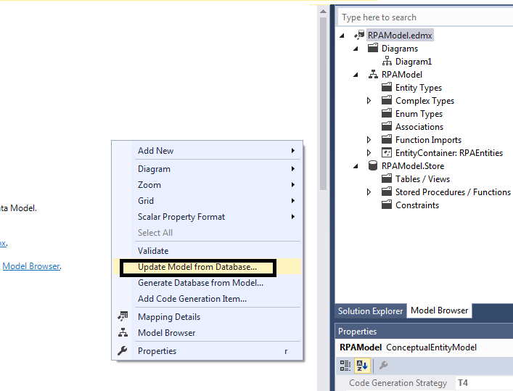

1. Select new store procedure to include in model

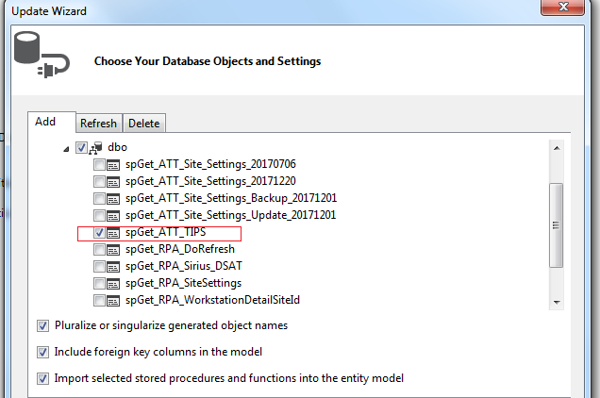

Now in file RPAModel.Context.cs you will be able to see the reference of the new store procedure

public virtual ObjectResult<spGet_ATT_TIPS_Result> spGet_ATT_TIPS(string workstation)

{

var workstationParameter = workstation != null ?

new ObjectParameter("workstation", workstation) :

new ObjectParameter("workstation", typeof(string));

return ((IObjectContextAdapter)this).ObjectContext.ExecuteFunction<spGet_ATT_TIPS_Result>("spGet_ATT_TIPS", workstationParameter);

}

1. CREATE SERVICE CONTRACT AND DATA CONTRACT, WHAT YOU ARE GOING TO RETRIEVE IN FILE IRAPService.cs

[ServiceContract]

public interface IRPAService

{

[OperationContract(IsOneWay = false)]

List<ATT_Tips> GetTips();

}

[DataContract]

public class ATT_Tips

{

[DataMember]

public string TIP { get; set; }

[DataMember]

public string LINK { get; set; }

}

1. In DataAccess create reference to StoreProcedure

public static ATTSiteSettings GetATTSite(string workstation)

{

ATTSiteSettings details = new ATTSiteSettings();

using (var entities = new RPAEntities())

{

var settings = entities.spGet_ATT_Site(workstation).FirstOrDefault();

details.Dealer = settings.DealerCode;

details.LogLevel = settings.LogLevel.Value;

details.Store = settings.StoreCode;

}

return details;

}

For a list

public static List<ATT_Tips> GetTips()

{

List<ATT_Tips> lista = new List<ATT_Tips>();

using (var entities = new RPAEntities())

{

var settings = entities.spGet_ATT_TIPS().ToList();

foreach (var item in settings)

{

ATT_Tips ss = new ATT_Tips();

ss.TIP = item.TIP;

ss.LINK = item.LINK;

lista.Add(ss);

}

}

return lista;

}

public static List<ATT_Tip> GetTips()

{

List<ATT_Tip> lista = new List<ATT_Tip>();

using (var entities = new RPAEntities())

{

lista= entities.spGet_ATT_TIPS().Cast<ATT_Tip>().ToList();

}

return lista;

}

1. Implement call in RPAService.scv.cs this one is the one that you will see from the reference

public List<ATT_Tips> GetTips()

{

List<ATT_Tips> details = null;

try

{

details = DataAccess.GetTips();

}

catch (Exception ex)

{

log4net.Config.XmlConfigurator.Configure();

log.Error(ex.ToString());

}

return details;

}

Or DataTable

public static DataTable GetTips()

{

DataTable dtTips = new DataTable();

dtTips.Columns.Add("TIP", typeof(string));

dtTips.Columns.Add("LINK", typeof(string));

try

{

using (RPAServiceClient client = new RPAServiceClient())

{

var settings = client.GetTips();

foreach (var item in settings)

{

dtTips.Rows.Add(item.TIP, item.LINK);

}

}

}

catch (Exception ex)

{

log4net.Config.XmlConfigurator.Configure();

log.Error(ex.ToString());

}

return dtTips;

}

1. Rebuild
2. Update reference

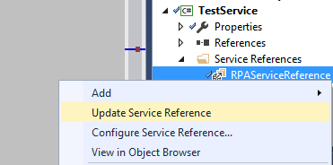

1. Test

si lo prueba local BasicHttpBinding_IRPAService

si lo prueba remoto BasicHttpsBinding_IRPAService

using (RPAServiceClient client = new RPAServiceClient("BasicHttpBinding_IRPAService"))

{

//var site = client.GetATTSite("SSLDT-84DB4V1");

var site = client.GetTips();

int i = 0;

}

}

local

<endpoint address="http://localhost:53258/RPAService.svc"

binding="basicHttpBinding"

bindingConfiguration="BasicHttpBinding_IRPAService"

contract="RPAServiceReference.IRPAService"

name="BasicHttpBinding_IRPAService" />

remote

<endpoint address="https://orliwv024.na.convergys.com/RPAServiceDev/RPAService.svc"

binding="basicHttpBinding"

bindingConfiguration="BasicHttpsBinding_IRPAService"

contract="RPAServiceReference.IRPAService"

name="BasicHttpsBinding_IRPAService" />

Agregar para libreria

1. ServiceLibrary.cs

public static List<ATT_Tips> GetTips()

{

List<ATT_Tips> details = null;

try

{

using (RPAServiceClient client = new RPAServiceClient())

{

var settings = client.GetTips();

foreach (var item in settings)

{

ATT_Tips ss = new ATT_Tips();

ss.TIP = item.TIP;

ss.LINK = item.LINK;

details.Add(ss);

}

}

}

catch (Exception ex)

{

log4net.Config.XmlConfigurator.Configure();

log.Error(ex.ToString());

}

return details;

}